**In this part you will begin building your project. Start by designing and developing the static travel blog website. Design the website layout using HTML and CSS. Create engaging content with captivating photos and travel stories.**

**Step1:planning and structure**

* Home
* Blog posts
* About
* Contact us

**Step 2: Create HTML Structure**

Create a simple website for using HTML code

<!DOCTYPE html>

<html>

<head>

<title>My Travel Blog</title>

<link rel="stylesheet" type="text/css" href="style.css">

</head>

<body>

<header>

<h1>My Travel Blog</h1>

<nav>

<ul>

<li><a href="index.html">Home</a></li>

<li><a href="blog.html">Blog</a></li>

<li><a href="about.html">About</a></li>

<li><a href="contact.html">Contact</a></li>

</ul>

</nav>

</header>

<main>

<!-- Content goes here -->

</main>

<footer>

&copy; 2023 My Travel Blog

</footer>

</body>

</html>

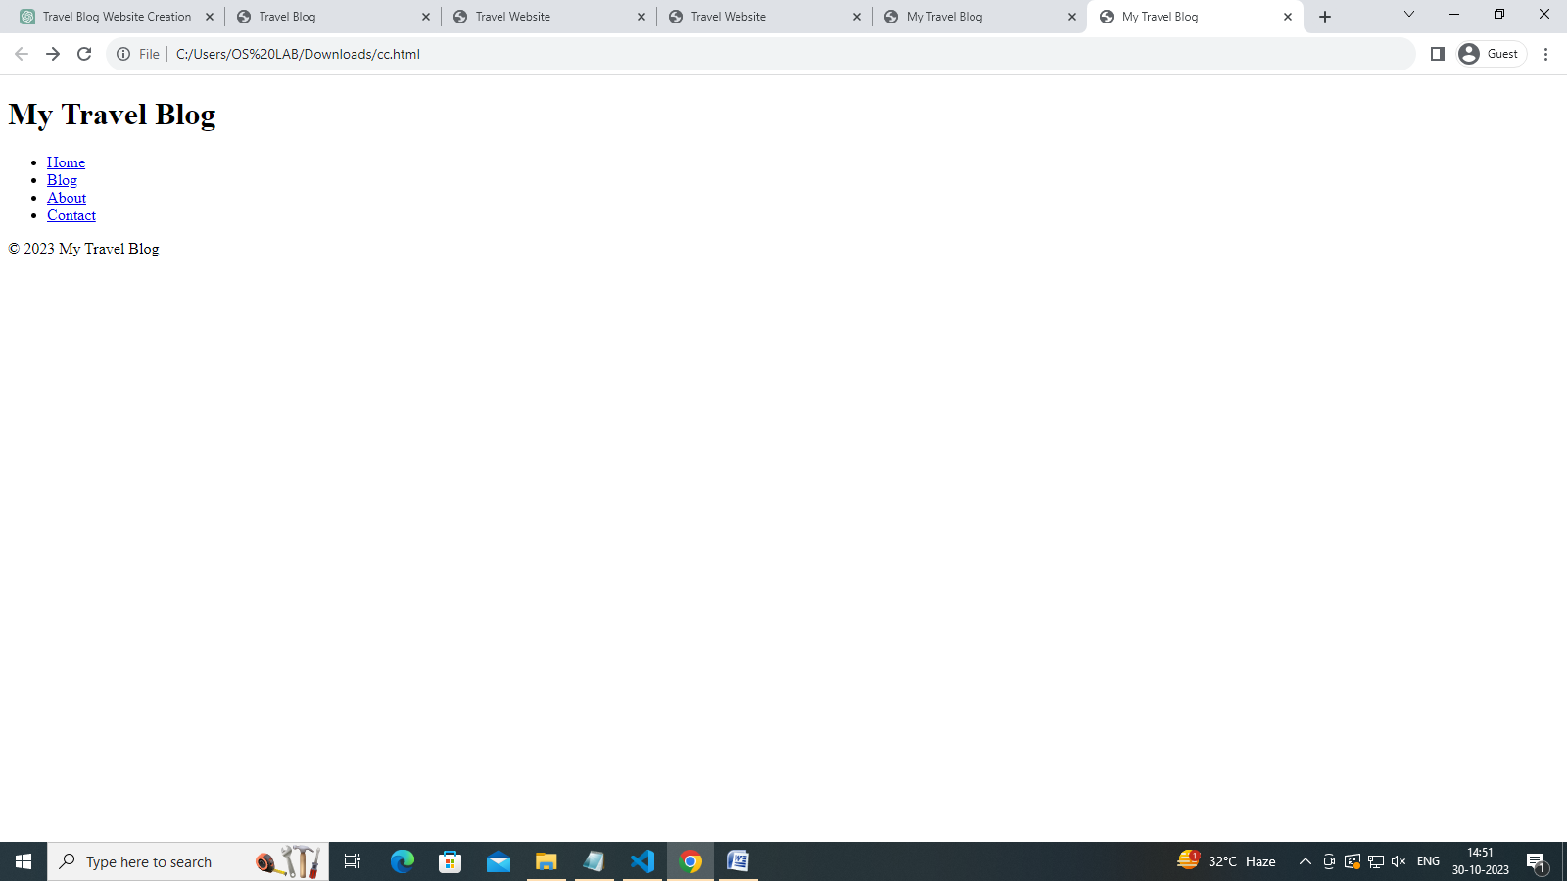

**Step3: add content**

Add content to our website

<!-- ... (previous HTML code) ... -->

<section class="destinations">

<h2>Popular Destinations</h2>

<div class="destination-card">

<img src="paris.jpg" alt="Paris, France">

<h3>Paris, France</h3>

<p>Experience the romance of the City of Love. Visit iconic landmarks like the Eiffel Tower and Louvre Museum.</p>

</div>

<div class="destination-card">

<img src="tokyo.jpg" alt="Tokyo, Japan">

<h3>Tokyo, Japan</h3>

<p>Discover the blend of tradition and modernity in Tokyo. Explore ancient temples and bustling neighborhoods.</p>

</div>

<!-- Add more destination cards here with images, titles, and descriptions -->

</section>

<section class="about">

<h2>About Us</h2>

<p>Welcome to TravelSite, your ultimate travel destination guide. We are passionate about helping you explore the world's most amazing places. Our mission is to provide you with the best travel experiences, tips, and recommendations.</p>

<p>With years of travel expertise, our team is dedicated to curating the perfect itineraries and travel information to make your dream vacation a reality. We aim to inspire your wanderlust and assist you in planning unforgettable journeys.</p>

</section>

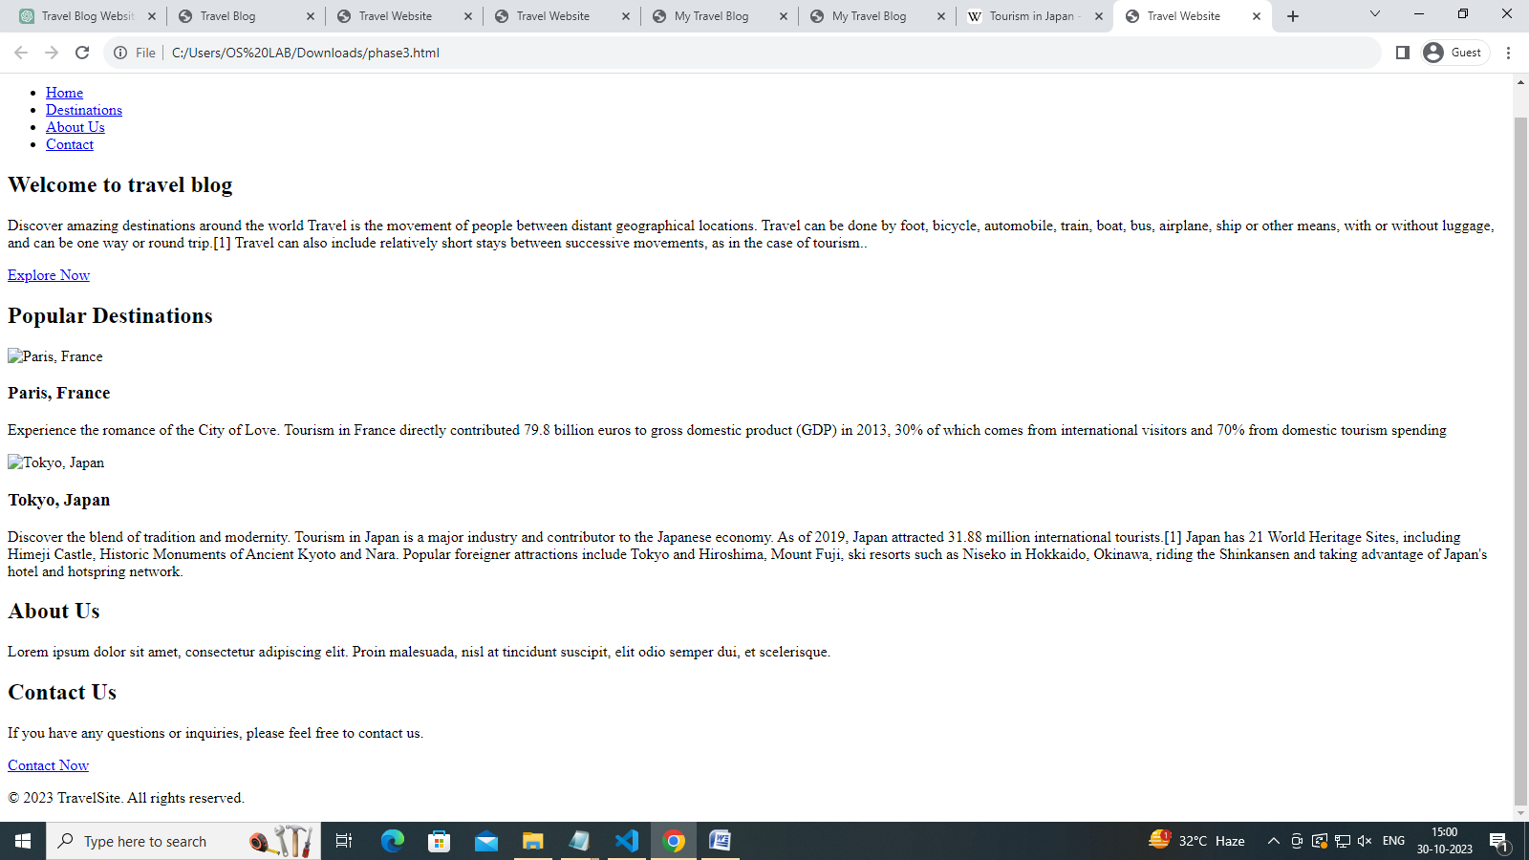

**Step 5: Link Pages**

In the navigation menu in the header, make sure to link to the corresponding HTML pages. For example:

html

Copy code

<li><a href="index.html">Home</a></li>

<li><a href="blog.html">Blog</a></li>

<!-- Add similar links for About and Contact page

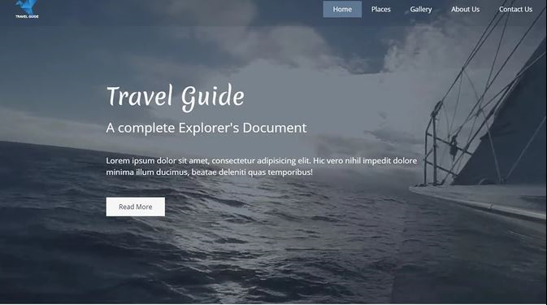

**Thank you**